***Source Code:***

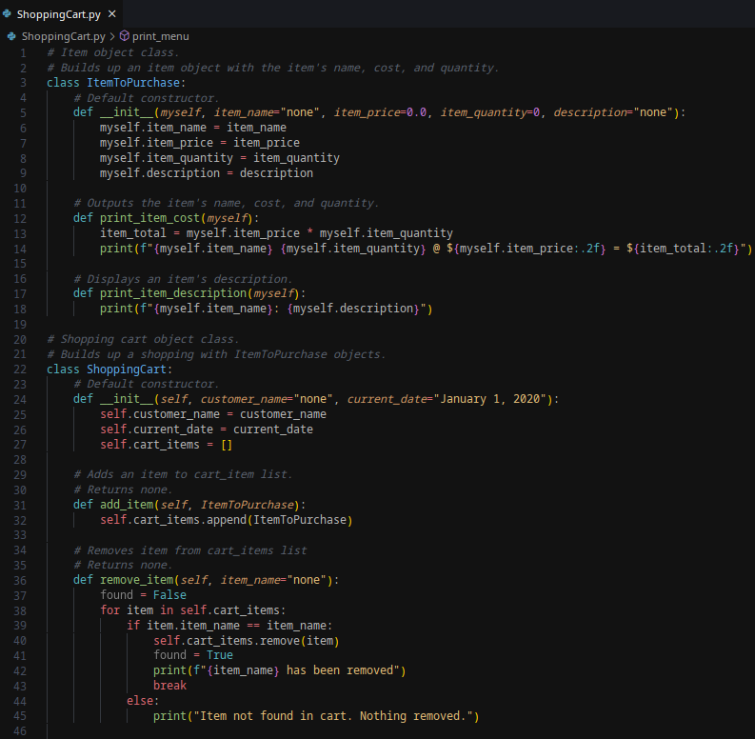

***Source Code Continued:***

***Source Code Continued:***

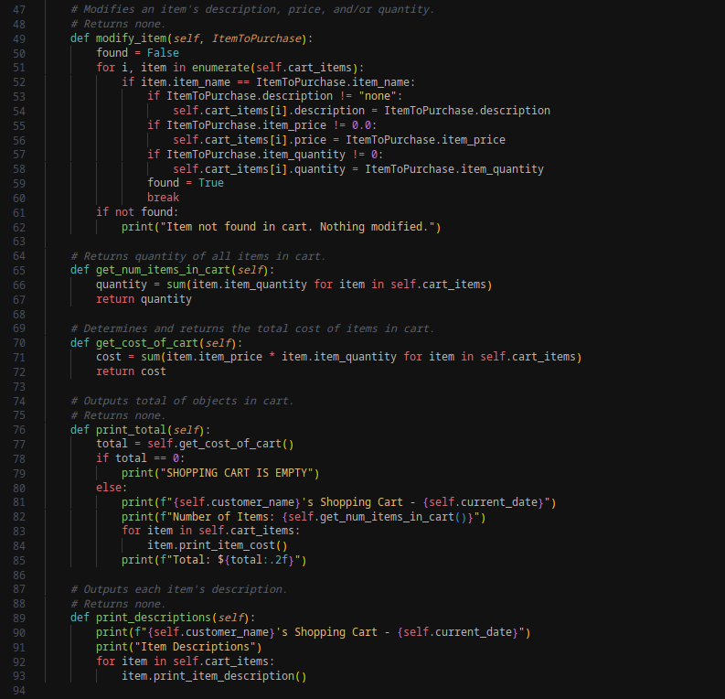

***Source Code Continued:*** 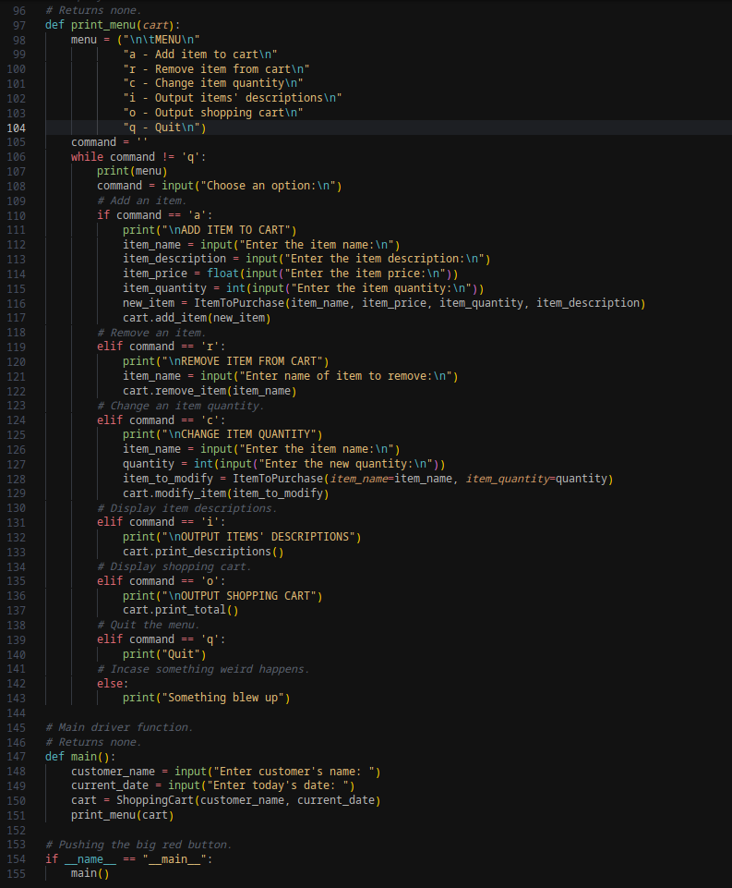

| ***Output*** | |
| --- | --- |
| ***Adding items:*** |  |
| ***Remove Items*** |  |
| ***Display Empty Cart and Quit*** |  |

[***Github Repo***](https://github.com/rt75272/CSC_500/tree/main/module_06/shopping)***:***

https://github.com/rt75272/CSC_500/tree/main/module_06/shopping